CHAPTER II
METHODOLOGIES
A. Existing and Proposed Algorithm Comparative Analysis
I. Existing algorithm
I.i Problems
II. Proposed Algorithm
II.i Objectives
III. Manual Simulation
III.i Existing Algorithm
III.i.a Problem 1
III.i.b Problem 2
III.i.c Problem 3
III.ii Proposed Algorithm
III.ii.a Problem 1
III.ii.b Problem 2
III.ii.c Problem 3
IV. Computerized Simulation
IV.i Existing Algorithm
IV.i.a Problem 1
IV.i.b Problem 2
IV.i.c Problem 3
IV.ii Proposed Algorithm
IV.ii.a Problem 1
IV.ii.b Problem 2
IV.ii.c Problem 3

I. Existing algorithm
Phase 1: Propagation
Each propagation involves the following steps:
Step 1. Forward propagation of a training pattern's input through the neural network in order to generate the propagation's output activations.
Step 2. Backward propagation of the propagation's output activations through the neural network using the training pattern target in order to generate the deltas (the difference between the targeted and actual output values) of all output and hidden neurons.
Phase 2: Weight update
For each weight synapse follow the following steps:
Step 1. Multiply output delta and input activation based on the dimension of the neuron to get the gradient of the weight.
Step 2. Denote m input values.
Step 3. Initialize each of the m inputs (synapses) with a weight w1, w2, ...,
Step 4. The input values are multiplied by their weights and summed.
Step 5. The output is some function y = f(v) of the weighted sum.
Step 6. The output of a neuron (y) is a function of the weighted sum.
Step 7. Apply activation function.
Step 8. Subtract a ratio (percentage) from the gradient of the weight.
Repeat phase 1 and 2 until the performance of the network is satisfactory.
I.i Problems
Problem 1: Algorithm consumes computing resources exponentially when calculating the local minimum cost value of a given set with a large number of elements.
Problem 2: Algorithm describes or classifies random error or “noise” when fitting a model to a set of training data resulting to poor generalization.
Problem 3: Algorithm gets stuck and the network gets trapped into a local minima caused by the neuron saturation layer resulting to poor error rate correction.

III. Manual Simulation
The basic structure:
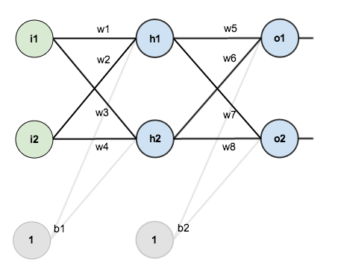
In order to have some numbers to work with, here are the initial weights, the biases, and training inputs/outputs:
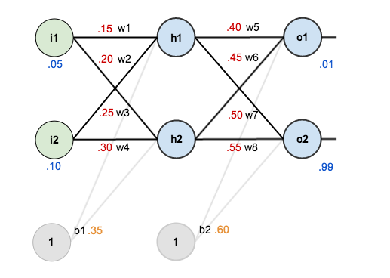

Here’s how we calculate the total net input for h₁:
net_{h1} = w₁ * i₁ + w₂ * i₂ + b_{1 *} 1
net_{h1} = 0.5 * 0.05 + 0.2 *0.1 + 0.35 * 1

We then squash it using the logistic function to get the output of h₁:
out_{h1 =} 1/1+e^{-net}_{h1} = 1/1+e^{-0.3775} = 0.593269992
Carrying out the same process for h₂ we get:
out_{h2} = 0.596884378
We repeat this process for the output layer neurons, using the output from the hidden layer neurons as inputs.
Here’s the output for o₁:
net_{o1} = w₅ * out_{h1} + w₆ * out_{h2} + b_{2 *} 1
net_{o1} = 0.4 * 0.593269992 + 0.45 * 0.596884378 + 0.6 * 1 = 1.105905967
out_{o1} = 1/ 1+e^{-net}_{o1} = 1/1+e^{-1.105905967} = 0.75136507
And carrying out the same process for o₂ we get:
out_{o2} = 0.772928465

Calculating the Total Error
We can now calculate the error for each output neuron using the squared error function and sum them to get the total error:
∑_{total =} ∑1/2(target-output)²
Some sources refer to the target as the ideal and the output as the actual.
The 1/2 is included so that exponent is cancelled when we differentiate later on. The result is eventually multiplied by a learning rate anyway so it doesn’t matter that we introduce a constant here.

For example, the target output for o₁ is 0.01 but the neural network output 0.75136507, therefore its error is:
E_{o1} = 1/2(target_{o1} – out _{o1})² = 1/2 (0.01 – 0.75136507) ² = 0.274811083
Repeating this process for o₂ (remembering that the target is 0.99) we get:
E_{o2} = 0.023560026
The total error for the neural network is the sum of these errors:
E_{total} = E_{o1} + E_{o2} = 0.274811083 + 0.023560026 = 0.298371109

The Backwards Pass
Our goal with backpropagation is to update each of the weights in the network so that they cause the actual output to be closer the target output, thereby minimizing the error for each output neuron and the network as a whole.

Output Layer
Consider w₅. We want to know how much a change in w₅ affects the total error, aka aE_{total}/aw₅.
aE_{total}/aw₅ is read as “the partial derivative of E_{total} with respect to w₅ “. You can also say “the gradient with respect to w₅ “.
By applying the chain rule we know that:

aE_{total}/aw₅ = aE_{total}/aout_{o1 *} aout_{o1}/aout_{o1} * amet_{o1}/aw₅
Visually, here’s what we’re doing:
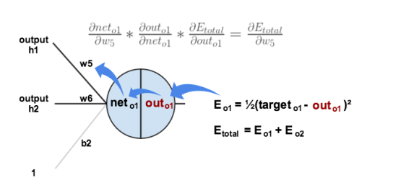
We need to figure out each piece in this equation.
First, how much does the total error change with respect to the output?
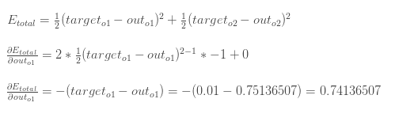
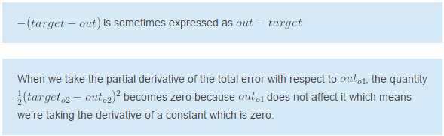Next, how much does the output of _{o1} change with respect to its total net input?
The partial derivative of the logistic function is the output multiplied by 1 minus the output:
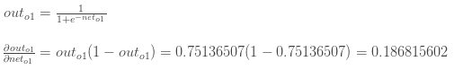
Finally, how much does the total net input of change with respect to ?
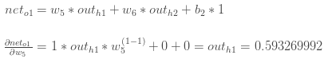
Putting it all together:
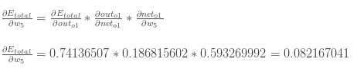
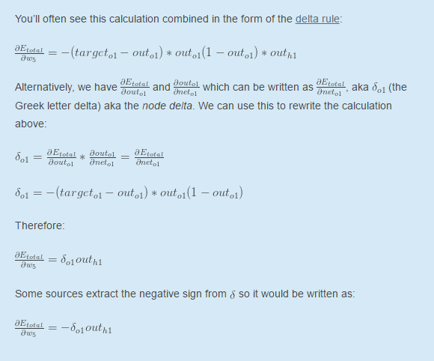To decrease the error, we then subtract this value from the current weight (optionally multiplied by some learning rate, eta, which we’ll set to 0.5):
We can repeat this process to get the new weights , , and :
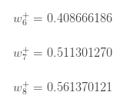
We perform the actual updates in the neural network after we have the new weights leading into the hidden layer neurons (ie, we use the original weights, not the updated weights, when we continue the backpropagation algorithm below).

Hidden Layer
Next, we’ll continue the backwards pass by calculating new values for w₁, w₂, w₃, and w₄.
Big picture, here’s what we need to figure out:
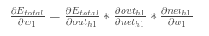
Visually:
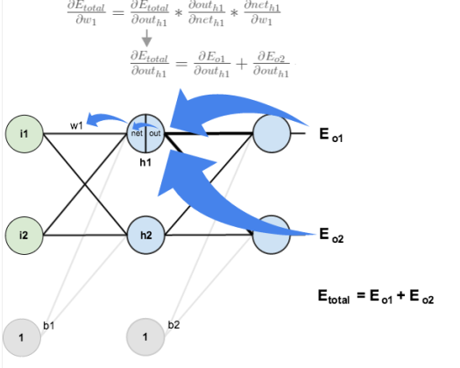
We’re going to use a similar process as we did for the output layer, but slightly different to account for the fact that the output of each hidden layer neuron contributes to the output (and therefore error) of multiple output neurons. We know that out_{h1} affects both out_{o1} and out_{o2} therefore the 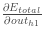 needs to take into consideration its effect on the both output neurons:
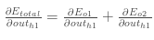
Starting with 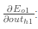
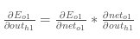
We can calculate 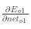 using values we calculated earlier:
And 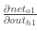 is equal to w₅:
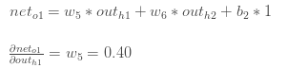
Plugging them in:
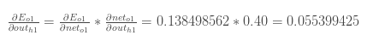
Following the same process for 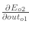, we get:
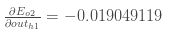
Therefore:
Now that we have 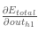, we need to figure out and then for each weight:
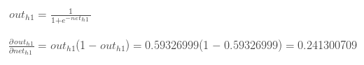
We calculate the partial derivative of the total net input to h₁ with respect to₁ the same as we did for the output neuron:
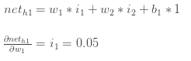
Putting it all together:
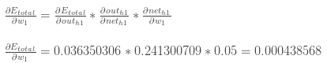
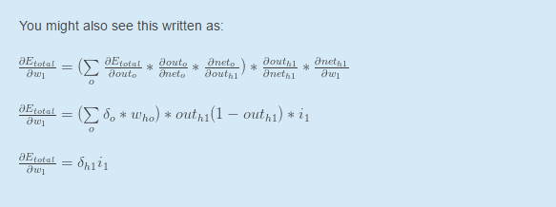
We can now update w₁:
Repeating this for w₂, w₃, and w₄
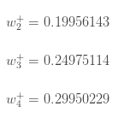
Finally, we’ve updated all of our weights! When we fed forward the 0.05 and 0.1 inputs originally, the error on the network was 0.298371109. After this first round of backpropagation, the total error is now down to 0.291027924. It might not seem like much, but after repeating this process 10,000 times, for example, the error plummets to 0.000035085. At this point, when we feed forward 0.05 and 0.1, the two outputs neurons generate 0.015912196 (vs 0.01 target) and 0.984065734 (vs 0.99 target).
III.i Existing Algorithm
III.i.a Problem 1
Here’s the output for o₁:
net_{o1} = w₅ * out_{h1} + w₆ * out_{h2} + b_{2 *} 1
net_{o1} = 0.4 * 0.593269992 + 0.45 * 0.596884378 + 0.6 * 1 = 1.105905967
out_{o1} = 1/ 1+e^{-net}_{o1} = 1/1+e^{-1.105905967} = 0.75136507
And carrying out the same process for o₂ we get:
out_{o2} = 0.772928465

III.i.b Problem 2

III.i.c Problem 3

